# E-Ticketing System

*STATE DIAGRAM*

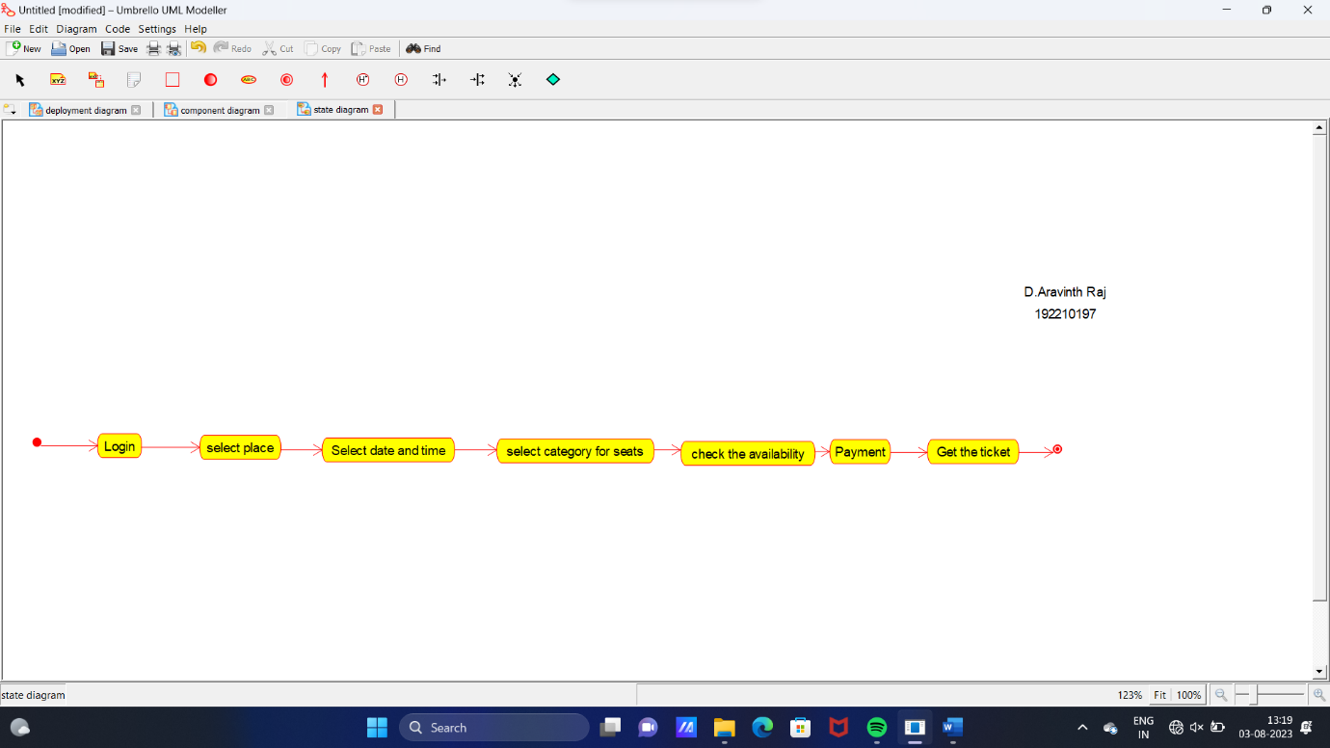

*SEQUENCE DIAGRAM*

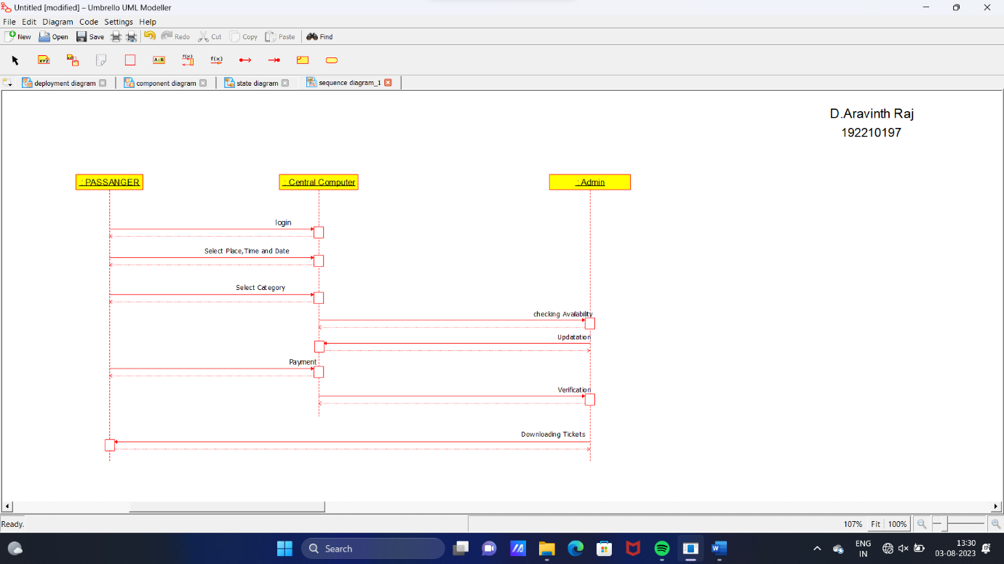

*DEPLOYMENT DIAGRAM*

\